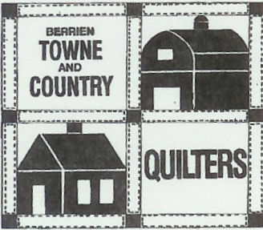

Berrien Towne and Country Quilters
2022 Membership

NAME FIRST________________________________ LAST_________________________________________

ADDRESS______________________________________________________________________________________

_______________________________________________________________________________________

EMAIL_________________________________________________________________________________________

HOME PHONE ________________________________ CELL PHONE _______________________________

BIRTHDAY (M/D) ___________________________

Membership booklet: (circle one) PRINTED or PDF

MAKE CHECKS PAYABLE TO: BTCQ
Mail to Sara Lawrick 3752 Lane Court Saint Joseph MI 49085

___________________________________________________________________________________________________

DATE PAID _________________________________________

RENEWAL____________NEW MEMBER ____________

REGULAR $30.00___________ (CHECK # or CASH__________)

JUNIOR $15.00____________ (CHECK # or CASH___________)

